



Implementation of encapsulation in a Bank Account transaction
LAB MANUAL

Disclaimer: The content is curated from online/offline resources and used for educational purpose only
Implementation of encapsulation in a Bank Account transaction

Objectives:
- To understand and implement encapsulation in Python.
- To create a class Bank Account with private attributes that are only accessible via public methods.
- To perform deposit and withdrawal operations using public methods while preventing direct access to sensitive account details (e.g., balance).
- To demonstrate how encapsulation promotes data security and integrity by restricting access to internal variables.
Problem Statement:
Creating a bank account system where a user can perform basic transactions like deposits and withdrawals. To protect sensitive information like the account number and balance, encapsulation should be used. The bank account attributes (such as account_number, holder_name, and balance) should be private and should only be accessible or modified via public methods, ensuring data integrity.
Procedure:
Task 1: Define the BankAccount Class with Encapsulation
Task 2: Implement Methods to Perform Deposits and Withdrawals
Task 3: Implement a Method to Check the Balance
Task 4: String Representation of the Bank Account
Task 5: Instantiate Objects and Display Details

Code:
Task 1: Define the BankAccount Class with Encapsulation
The __account_number, __holder_name, and __balance attributes are private because they are preceded by double underscores (__), which makes them inaccessible from outside the class. The __init__() constructor initializes the bank account with default values for account_number, holder_name, and balance.
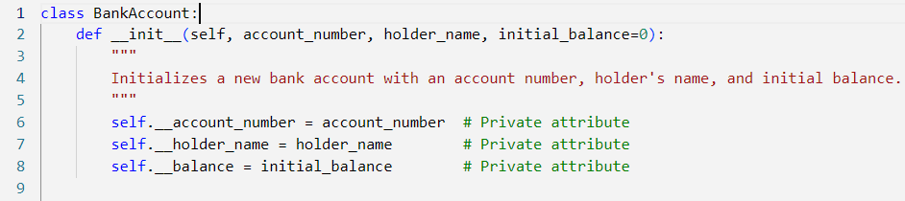

Task 2: Implement Methods to Perform Deposits and Withdrawals
Encapsulation ensures that balance manipulation can only happen through controlled methods like deposit() and withdraw(), safeguarding against unauthorized or incorrect modifications. The deposit() method increases the account balance by a positive amount. It ensures that the user can’t deposit negative values. The withdraw() method decreases the balance only if the user has sufficient funds. This ensures that the balance remains non-negative.

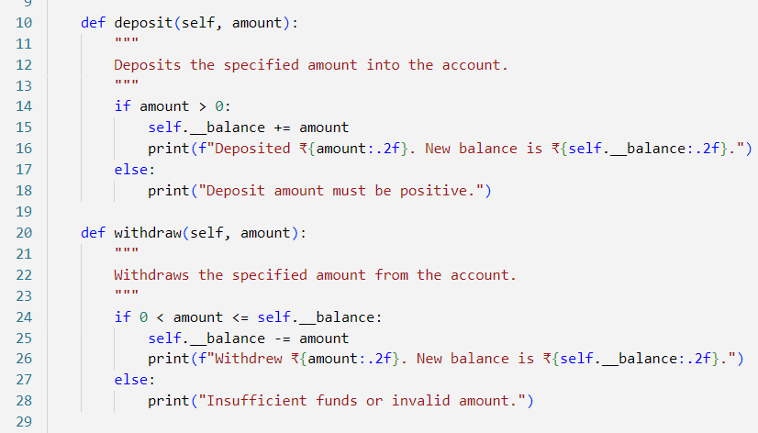

Task 3: Implement a Method to Check the Balance
The get_balance() method provides read-only access to the private __balance attribute, so users can check their balance without directly modifying it.

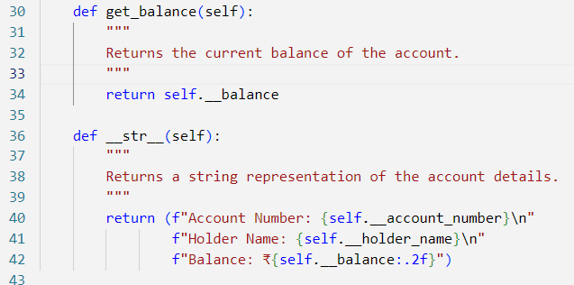

Task 4: String Representation of the Bank Account
The __str__() method returns a formatted string representing the account details, allowing for easy printing of account information.
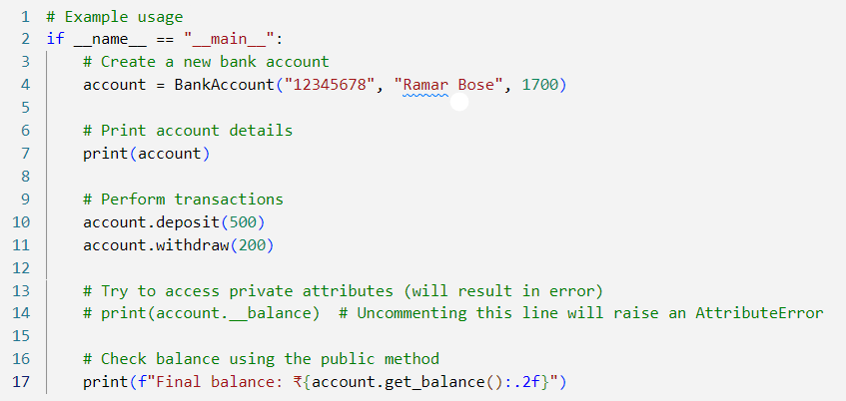
v
Output:
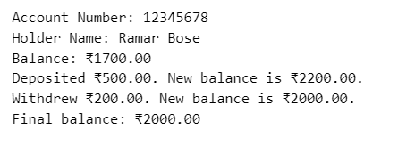
This program demonstrates how encapsulation is used in a BankAccount class to secure sensitive information like the balance and account number. By restricting direct access to these attributes, the program ensures that all interactions with the account data are safe and valid.

